|  |
| --- |
| Bottom text |
| Lab B |
| Sample text |

|  |
| --- |
| Jonathan Lai  214838445 |

# Program 1:

## Code:

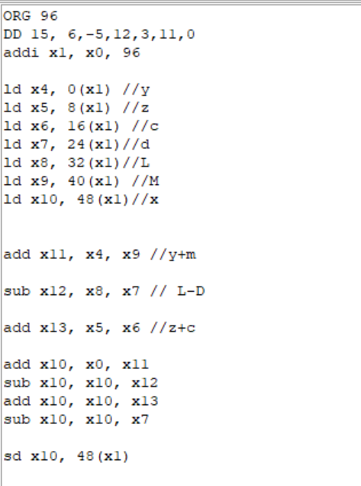

## After compile (Before run):

## Register/Memory

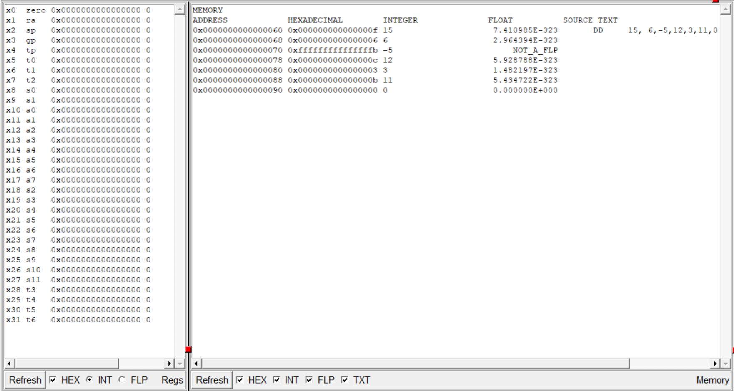

## Listing

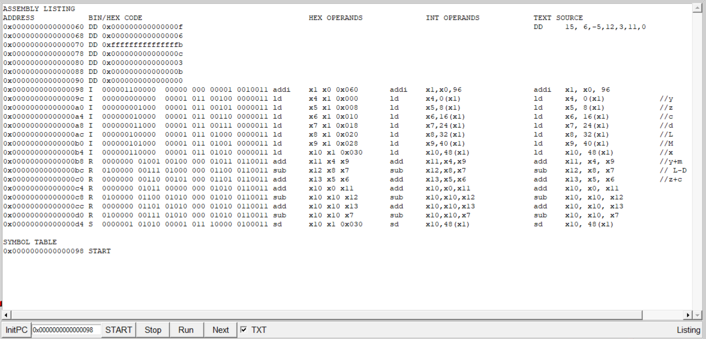

## After Run:

## Register/Memory

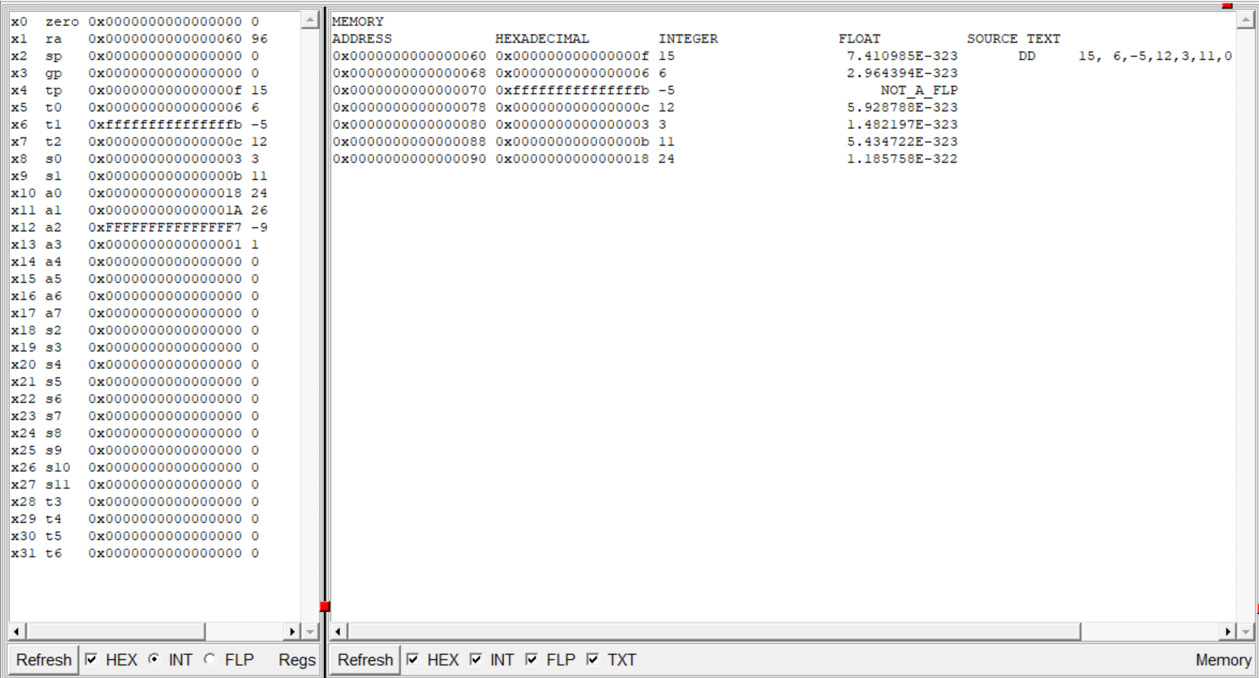

## Listing

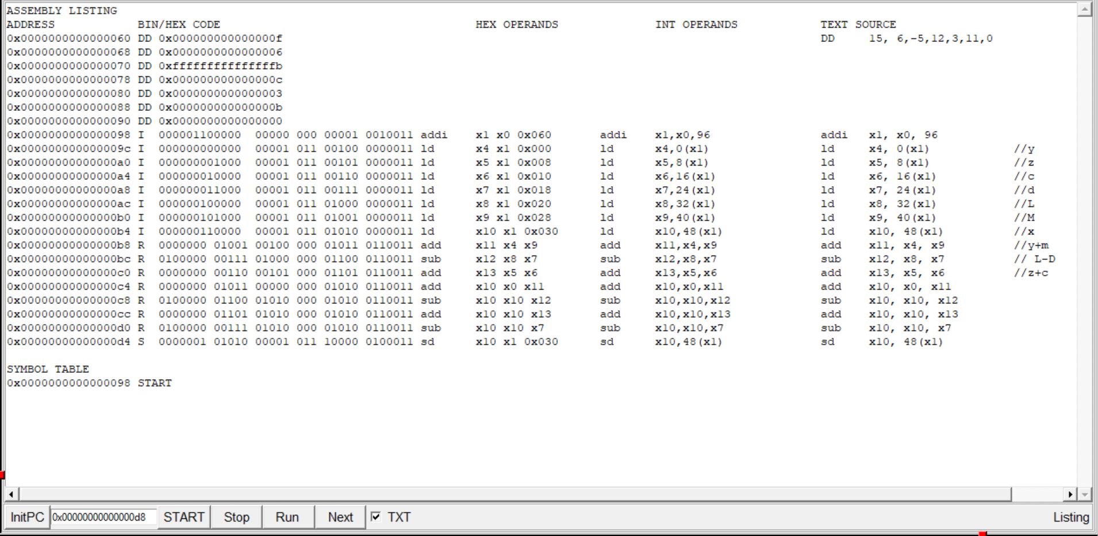

## Execution

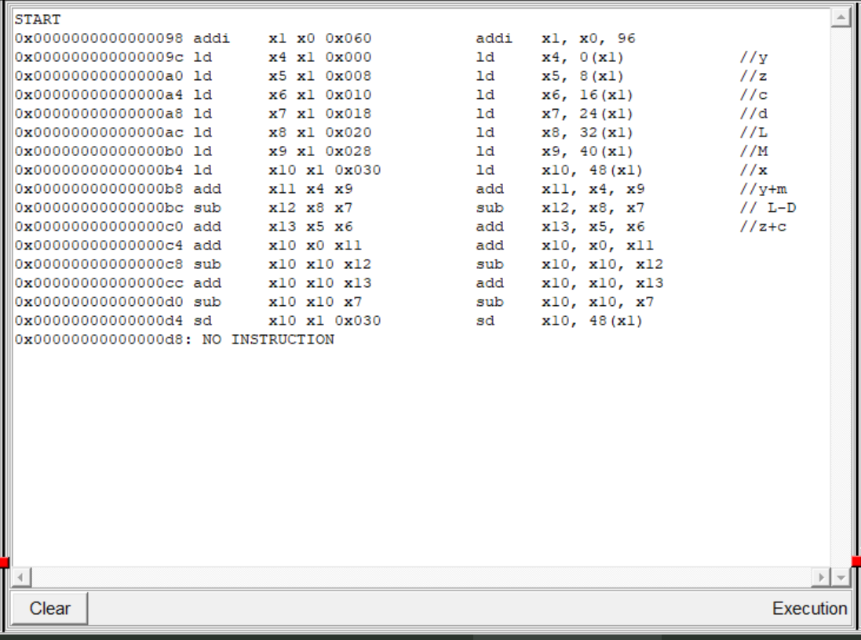

# Program v2:

## Code:

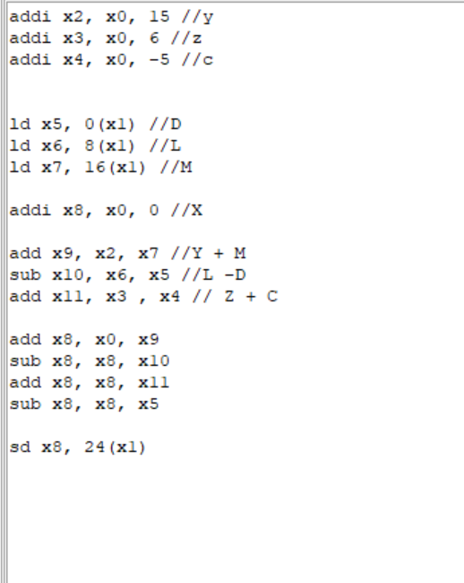

## Before Run(After compile):

### Register/Memory

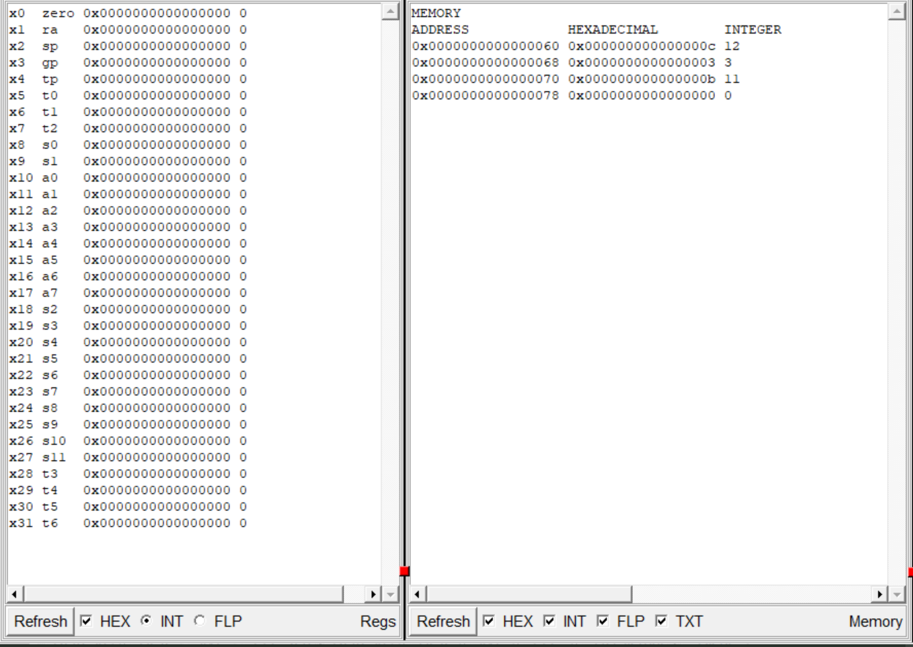

### Listing Window:

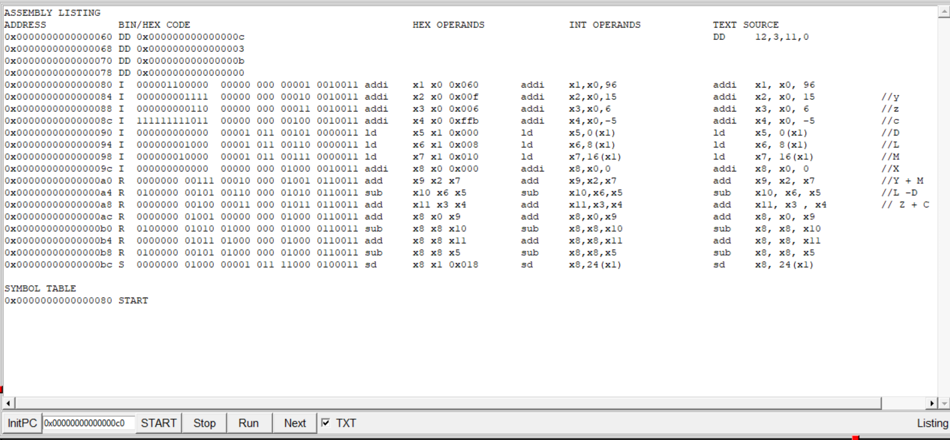

# After run:

## Memory/Register Window:

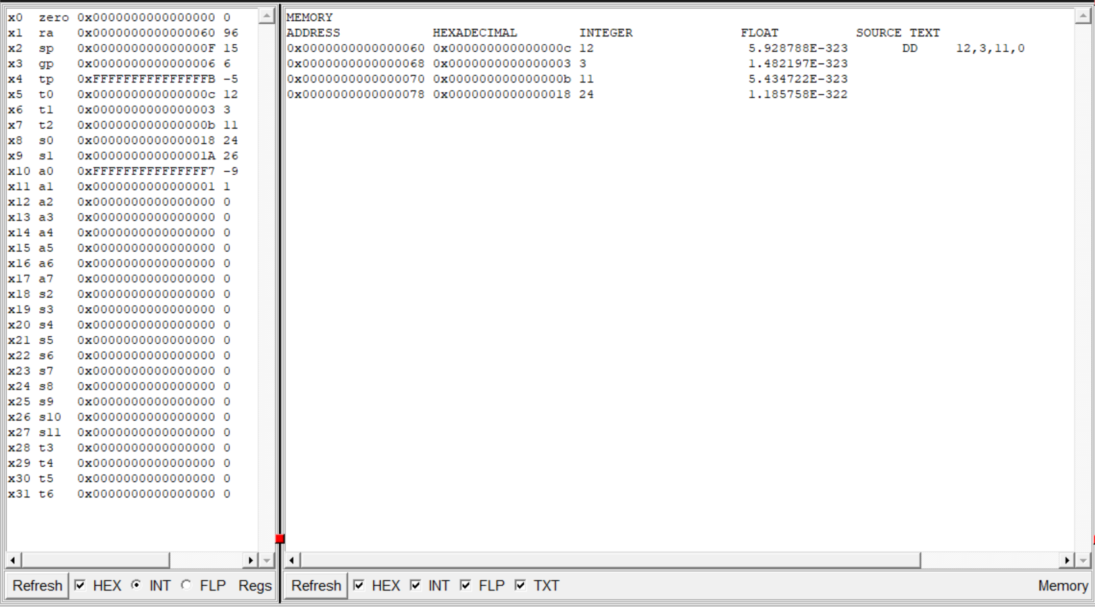

## Listing

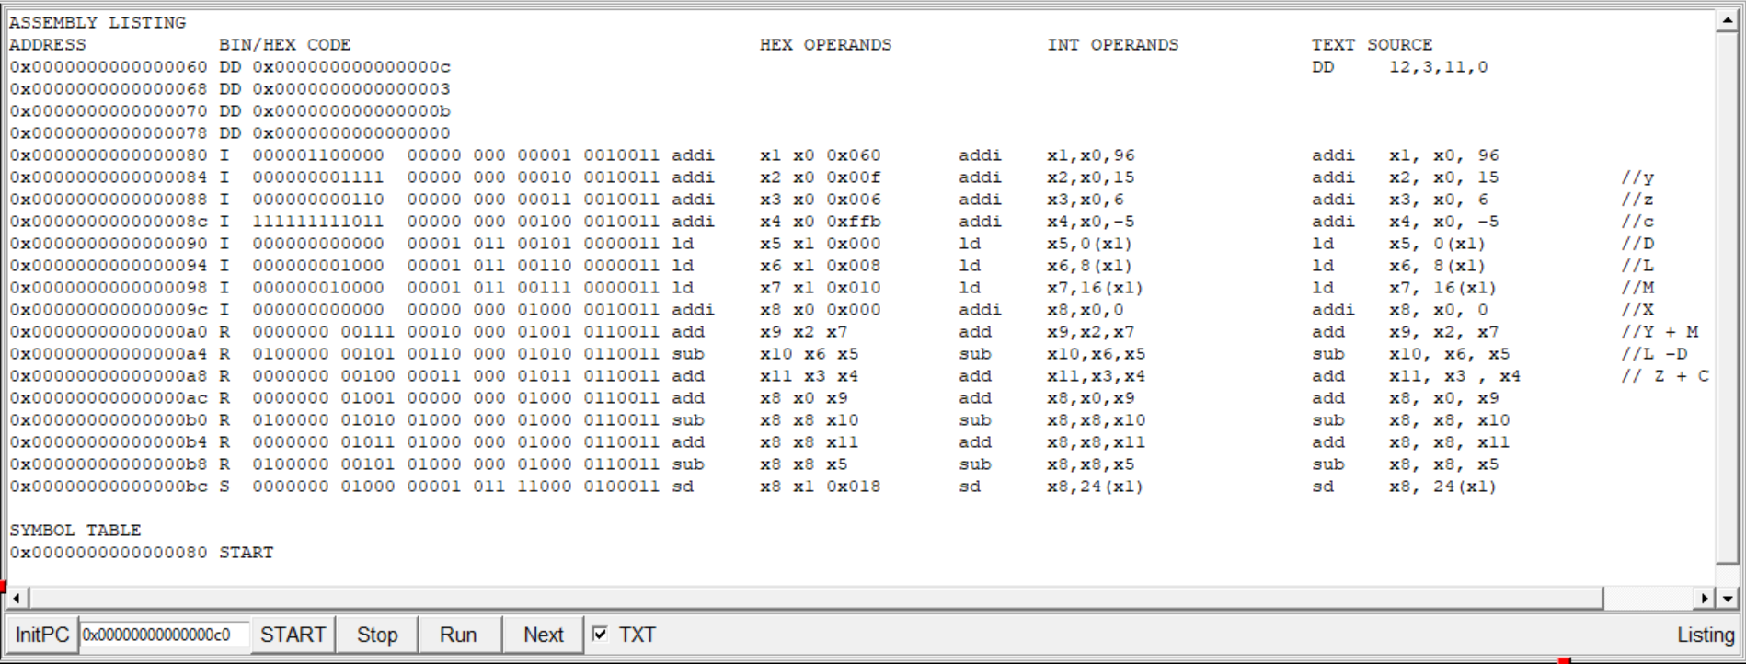

## Execution Window

